Hayton and Burnby Parish Council

www.haytonandburnbypc.co.uk

Tel: 01759 301386 Email; clerk@jigreen.plus.com

Clerk: Joanna Green, 29 Barmby Road, Pocklington, York, YO42 2DL

A meeting of Hayton and Burnby Parish Council will be held on **Thursday 1st December 2022** at 7.30pm in Hayton Village Hall. Members of the public are welcome to attend the meeting and may address the council during the Public Participation period. An agenda for the meeting is shown below.

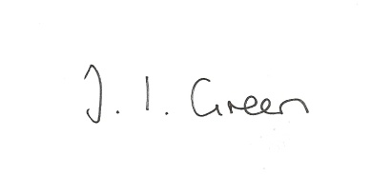Joanna Green, clerk to the council. 25/11/22

**140/22 Welcome and Apologies.**

**141/22 Declaration of Interest.** The Parish Councils Code of Conduct. To record any declarations of interest by any member in respect of items on this agenda.

**142/22 To approve the minutes** of the meeting held on 3rd November 2022

**143/22 To resolve that the meeting is temporarily suspended to allow for a period of public participation .**

**144/22 Matters arising from previous meetings**

Flood Plan

Street Lighting, Hayton

Fallen tree over the beck at Hayton

Old Bus Stop, Burnby

**145/22 Planning**

To receive notice of approval of :

Proposal 22/03017/PLF : Erection of a farm shop with associated car parking (Retrospective Application)

Location: North Farm Thorpe Le Street Road Thorpe Le Street East Riding Of

Yorkshire YO42 4LJ Applicant: Sellmor Farming

**146/22 Insurance - to consider quotes for 2023**

**147/22 Budget -** to consider the draft budget for the precept 2023/24

**148/22 Accounts**

Bank balance £11786.38

Clerk's salary November & allowance £134.70

Society of Local Council Clerks membership £73.00

Insurance premium

**149/22 Correspondence:**

Rural Services network bulletins

Humberside Police newsletters

Northern Gas Network newsletter

ERYC - temporary road closure Nunburnholme Road, Burnby

ERYC - Local Coordination Service, Your Life Your Way

Conservative Group - Western Parishes Liaison meeting minutes

Conservative Group - Help for Households

ERYC -Local Plan Update

East Riding Safeguarding Adults Board newsletter

ERYC - new Climate Change Strategy

ERYC - invitation to submit a topic for scrutiny

**150/22 Councillors reports**

**151/22 Date of next meeting**

**152/22 To consider excluding the press and public**

**To discuss the clerk's salary**