**Wolds Weighton Update for August 2019**

**1. Crime and ASB**

TFMV – Theft from motor vehicle

TOMV – Theft of motor vehicle

ASB – Anti-social behaviour



In Market Weighton it is positive to see that all but three offence categories have seen a reduction in the number of offences in July compared to June. It is also encouraging to see that Shop theft has seen a massive 83% reduction in the year. It is also worth noting that although some categories show that there has been a large percentage increase in crime compared to last year, this is primarily due to the number of offences committed last year being so low. For example, Drug Offences increased by 120% compared to the previous 12 months but in reality this was an increase of only 6 offences. Eleven reports of Drug related offences for the entire Wolds Weighton ward in a year is very low in comparison to other areas in the UK. It is also worth mentioning that although 32 Sexual Offences were reported over the last 12 months, not all of these will include a physical assault and some may be victims reporting historical offences.

**2. Crime issues of particular note**

**The following list shows some of the crimes that have occurred in the previous month in your area.**

* An insecure bicycle was stolen from outside a property in Market Weighton.
* Two purses were stolen from a horse box at a local show.
* A vehicle parked on a driveway in Goodmanham Road, Market Weighton has been damaged.

**3. Community Priorities**

The Neighbourhood Policing Team meet regularly with partners to ensure we have a multi-agency approach to local issues, individuals and problem solving.  These meetings are regularly attended by partners including Humberside Fire and Rescue Service, Youth and Family Support, Housing Officers, Environmental Health and the East Riding Anti-Social Behaviour Team.  We share information and resources to deal with local neighbourhood issues, in particular, those identified as causing the most harm in the community.

1. **Market Weighton Town Centre area (Evenings):**

We are to continue our high visibility patrols of the Market Weighton Town Centre area to deter potential anti-social behaviour (ASB). These patrols include regular checks on the High Street and peripheral areas of Londesborough Road Car Park, Scotts Croft Memorial Park, the town council building area and the area surrounding the Giant Bradley statue (periodic reports of youths causing annoyance). Criminal offenders will be challenged robustly, arrested or reported for summons. Penalty Notices for Disorder or warning letters may be used in appropriate cases however, those who offend should expect to be arrested and dealt with if their anti-social behaviour amounts to criminal offending.

1. **Youths Causing Annoyance (Evenings):**

Officers will continue patrols in the areas of Aspen Close, the park, the monkey run & football field due to regular reports of low level anti-social behaviour. Anyone caught engaging in such activities will be dealt with jointly with the East Riding of Yorkshire Council.

1. **Vehicle related nuisance**

To reduce anti-social behaviour (ASB) and its impact on the communities within the Wolds Weighton area as well as taking positive action against offenders who cause ASB with their vehicles. Hotspot areas will be checked regularly and any drivers using their cars to cause alarm or distress will be considered for warnings and possible seizure of their vehicles under Section 59 of the Police Reform Act.

**4. Crime Prevention Advice**

**Going on your holidays?**

**Remember home security**

Imagine that you have returned home after a fantastic holiday to discover your home has been burgled…it is not something the police want anyone to go through.   
  
Just because you are on holiday does not mean burglars are taking time off too and if it looks like you are away then your home could become a target. We are urging everyone to check their holiday security before they go away and ensure their holiday is one to remember for the right reasons.  
  
Follow our simple tips to secure your home against burglars:

Make sure your windows and doors are locked. If you have a burglar alarm turn it on and leave the key or passcode with a family member or trusted neighbour.

Remove and secure items that may be used to break in or climb into your home and lock your outbuilding so burglars can’t use the tools inside.

Use automatic timer-switches in different rooms to turn on lights and perhaps a radio when it gets dark.

Ask a trusted neighbour or family member come round and open and close curtains, plus move the post, so it looks like people are coming and going at your home.

Cancel any newspaper or milk deliveries.

Don't advertise that you are away. Social networking sites like Facebook and Twitter can be a risk if people know you are away and your home is empty.

Work with your neighbours to keep an eye on each other's homes. Neighbourhood Watch and Neighbourhood Networks encourage this type of community spirit and long term it may be worth joining one or setting one up in your street. For details visit: [www.ourwatch.org.uk](http://www.ourwatch.org.uk/) or contact your local policing team.

Never leave keys anywhere near the front door; burglars know where to look. Consider fitting a letterbox cage or other restrictor to prevent burglars from putting their hands or gadgets through and opening the latches from the inside.

Keep valuables out of sight and don’t leave them where they can be seen through a window.

If you conceal valuables in your home, avoid obvious hiding places such as your sock drawer or in a fake food can in the kitchen – burglars are wise to this trick.

Try not to leave anything you would hate to lose in the house while you are away.

**5. News and appeals**

On 31/07/19, Peter Gorcik, 50, of Holme Road, Market Weighton, appeared in court and pleaded guilty to driving a motor vehicle whilst over the prescribed alcohol limit. He is disqualified from driving for 16 months and ordered to pay fines totalling £235.

**EWE need to make the right call**

If there were sheep in your garden, is the emergency 999 number the one you would call?

Unbelievably, this did happen and was a genuine call from a man requesting police as there were sheep in his garden and he believed they were going to eat his children.

We receive numerous bizarre and inappropriate calls to our 999 and 101 lines, including a call about how to pay council tax, one from a woman concerned as her washing machine wouldn’t stop spinning, a caller wanting us to investigate the owners of a cat and a call about a rat running round in a house! Extracts of some of these calls can be listened to here:

These calls not only increase demand in the Force Control Room (FCR), but for someone who is in a dangerous situation and in desperate need of our service, it could potentially cost them their life.​

FCR Superintendent Tracy Bradley said: “When the days get longer and the weather warms up we do tend to see an increase in calls for our service and we need people to please, make the right call.

“We prepare for this each year, having extra staff on shift to answer calls, having our breaks at times when we were know there are less calls and limiting the number of people that can take time off across the busy summer period.

“However inappropriate calls to our 999 and 101 lines can have a major impact, causing delays in getting through for people that genuinely need our assistance and the 999 service.

“At best, that means people calling 101 have to wait longer before we can deal with their call. At worst, it could be the difference between life and death.

“I want to be clear, if you call 999 inappropriately we will hang up as soon as we have established that you’re not calling about a genuine emergency. I make no apology for that.

“We will not risk delaying someone whose life is in danger getting through to us because someone has called 999 to report their washing machine is faulty.

“Not all the inappropriate calls we receive are done maliciously – some come from vulnerable people and where that’s the case our teams do everything they can to ensure that the caller is safe and has the right advice and support.

“However, many are from people that don’t understand that 999 is for emergencies only and that there are other ways to find out advice and information or get in touch with us.

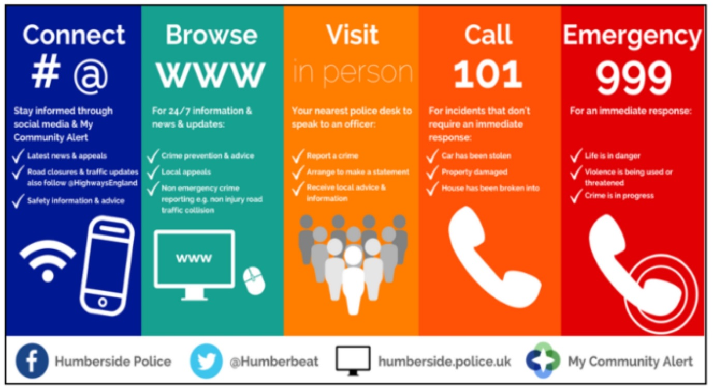“The below graphic gives some information about when to call 999 and when 101 or another service would be more appropriate. Please share it with your friends and family or even print off a copy to have handily available should you ever need anything from us.”

**6. Meet your officers.**

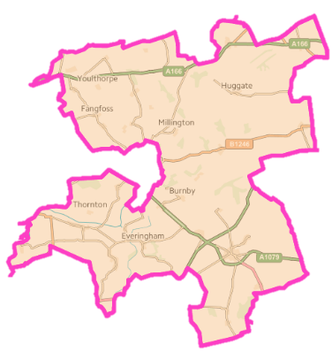

**PCSO Nicola Cliffe** is one of the PCSOs responsible for policing the Wolds Weighton ward. You can meet Nikki next at Market Weighton Town Council, 37 High Street. Market Weighton on:

* Tuesday 27th August (16:00- 17:00 hrs)
* Monday 2nd September- (11:00- 13:00 hrs)

**PCSO Laura Hudson** is one of the PCSOs responsible for policing the Wolds Weighton ward. You can meet Laura next at:

* Wetwang Coffee Morning on Tuesday 27th August (10:30 -12noon)
  + - Market Weighton Methodist Church onWednesday 28th August (11:00 – 12noon)