Wolds Weighton Update for November 2018

1. Crime and ASB
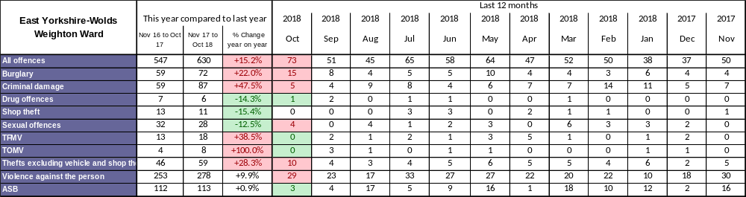

TFMV – Theft from motor vehicle
TOMV – Theft of motor vehicle
ASB – Anti-social behaviour

Detailed crime and ASB data for your area can be obtained by visiting www.police.uk and following the ‘Find your Neighbourhood’ link. Also details of any particular crimes or series of crimes of note e.g. serious assaults, run of Hanoi burglaries.

As we know statistics can be interpreted in many ways but, as a general rule, it is safe to say people in living in the East Riding are less likely to be the victim of crime than people living in other areas served by Humberside Police. The headlines will say that overall crime in your area is rising, with a projected increase this year when compared to last. It is important to put the data in context and point out that the primary reason for the overall increase is the rise in offences under the category ‘Violence against the person’. This is due to the increase in stalking and harassment offences that we now record under National Crime Recording Standards (NCRS). Many of these offences are committed online, involving people who already know each other, and previously would have been dealt with without the need to record a criminal offence.

We also now have Local Intelligence Officers back in the community, they are working hard to identify those responsible for burglaries and thefts of motor-vehicles in the area.

2. Crime issues of particular note
The following list shows some of the crimes that have occurred in the previous month in your area.
- A secure garden shed in Princess Road, Market Weighton was broken into and searched.
- Entry was gained into an insecure garage in Market Weighton and an insecure vehicle was searched.
- A stunt mountain bike was stolen from an insecure shed in Market Weighton.
- Entry was gained (via a rear door) into a secure property in Market Weighton and 2 bags containing various items were taken.
- Entry was gained into a secure car parked on a driveway but nothing was taken.
- A suspect was seen trying the door handle of a secure car parked at a property.
- A suspect gained entry into a property via an insecure rear kitchen window but was then disturbed by the home owner and fled.

3. Community Priorities
The Neighbourhood Policing Team meet regularly with partners to ensure we have a multi-agency approach to local issues, individuals and problem solving. These meetings are regularly attended by partners including Humberside Fire and Rescue Service, Youth and Family Support, Housing Officers, Environmental Health and the East Riding Anti-Social Behaviour Team. We share information and resources to deal with local neighbourhood issues, in particular, those identified as causing the most harm in the community.

- Market Weighton Town Centre area (Evenings):
Throughout November we are to continue our high visibility patrols of the Market Weighton Town Centre area to deter potential anti-social behaviour (ASB). These patrols include regular checks on the High Street and peripheral areas of Londesborough Road Car Park, Scotts Croft Memorial Park, the town council building area and the area surrounding the Giant Bradley statue (periodic reports of youths causing annoyance). Criminal offenders will be challenged robustly, arrested or reported for summons. Penalty Notices for Disorder or warning letters may be used in appropriate cases however, those who offend should expect to be arrested and dealt with if their anti social behaviour amounts to criminal offending.

- Youths Causing Annoyance (Evenings):
Officers will continue patrols in the areas of Aspen Close, the park, the monkey run & football field due to regular reports of low level anti-social behaviour. Anyone caught engaging in such activities will be dealt with jointly with the East Riding of Yorkshire Council.

- Vehicle related nuisance
To reduce anti-social behaviour (ASB) and its impact on the communities within the Wolds Weighton area as well as taking positive action against offenders who cause ASB with their vehicles. Hotspot areas will be checked regularly and any drivers using their cars to cause alarm or distress will be considered for warnings and possible seizure of their vehicles under Section 59 of the Police Reform Act.

4. Crime Reduction Advice

GOING SHOPPING? GOING OUT?

Don’t give opportunist thieves the chance to bag your belongings. It doesn’t matter if you are out shopping or going out for a social event, always make sure you stay alert at all times. By taking some simple steps you can help protect yourself and your belongings:

DON’T LEAVE YOUR HANDBAG UNATTENDED in shopping baskets, trolleys, pushchairs or mobility scooters. In cafes and restaurants keep your bags on your lap, between your feet or place the strap around a chair leg. (Don’t hang your bag on the back of your chair where you can’t keep an eye on it.)

KEEP YOUR HANDBAG CLOSE TO YOU and closed at all times. Choose a bag that can be zipped up or closed and get into the habit of checking that its fully fastened up after each time you have needed to get something out of it. Ideally your purse and phone should be well hidden and tucked away out of sight and out of easy reach of pickpockets.

Be particularly careful on public transport, keep your bag where you can see it. If you carry a rucksack, wear it on your front rather than on your back or over your shoulder.

DON’T LEAVE YOUR MOBILE PHONE ON THE TABLE. Mobile phones are frequently targeted by thieves and can easily be swiped when your back is turned even just for a minute.

KEEP THE AMOUNT OF VALUABLES INSIDE HANDBAGS TO AN ABSOLUTE MINIMUM and try not to carry large amounts of cash around with you.

BE MINDFUL OF DISTRACTIONS. Thieves working in pairs may try to divert your attention in order to steal your handbag or pick pocket your purse or phone from within. Avoid carrying too much around with you, the more bags you’ve got the more vulnerable you are. If you need to take shopping back to your car, put your bags in the car boot – don’t leave them where they can be seen eg in a footwell or on a back seat.

5. News and appeals

Halloween 2018
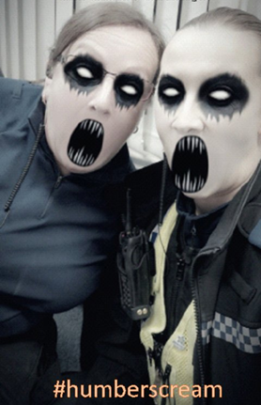
The Wolds Weighton Community Policing Team were on duty for Halloween night, we saw lots of wonderful costumes. We are happy to announce that over the whole day of Wednesday 31st October 2018 we had no calls for service for any anti-social behaviour in Pocklington Provincial area. PCSO 7702 EMERTON & PCSO 7508 CLIFFE got into the spirit before taking their masks off and conducting high visibility throughout the evening until 23:00 #humberscream

Shopping Online this Christmas – Safety Message
It's that time of year again folks. The busiest time of year for online shopping is also the busiest time for online criminals. Do not make it easy for fraudsters and criminals. Read our expert, easy to follow advice on the link below #onlineshopping #onlineatchristmas #safechristmas
https://www.getsafeonline.org/christmas/

Community Alert Sign-up
Do you want to be kept informed about local issues? Hear from your local officers by signing up to our free messaging service My Community Alert now! If you're not already signed up do it here: https://www.mycommunityalert.co.uk/
If you need help signing up then come along to the Community Alert and Neighbourhood Watch Event as detailed below in the “Meet your Officer” section. Receive real time alerts from your local officers and select what type of information you want to receive and how you would like to receive it.


HANOI BURGLARY (HOUSE BURGLARY ALONG WITH STEALING THE VEHICLE ‘TWO IN ONE’
A burglary has taken place in Main Street, Melbourne between Tuesday 6th November 2018 at 10pm to Wednesday 7th November 2018 at 7:30am. Unknown persons gain entry to the rear of the property by attacking the patio doors. Keys to a white BMW Series 1 VRM of YA17TGN and the vehicle was stolen with a from the drive way If you are aware of any CCTV or have information regarding the incident contact Humberside Police quoting – 16/116528/18

Remembrance Sunday
Sunday 11th November 2018 marked 100 years since the end of the First World War. We would like to say thank you to the generation who helped shape our futures and gave their tomorrow for our today. Officers were out across the region on Sunday 11th supporting Remembrance Sunday events & keeping you safe.

Importance of reporting incidents/crimes
Just a reminder that it is really important you report any crimes or suspicious incidents to us. This can be either via 999 or the 101 phone number, via our web site (www.humberside.police.uk), or personally at a police station or to an officer in the street. Only by reporting the crime/incident can we be aware of it. Once we are aware we may not be able to do anything about it immediately but the report will form part of a wider picture which helps inform where we direct officers to patrol and focus activity. So please ….. take the time to report a crime/incident in the knowledge your time is not wasted.

The Wolds Weighton ward
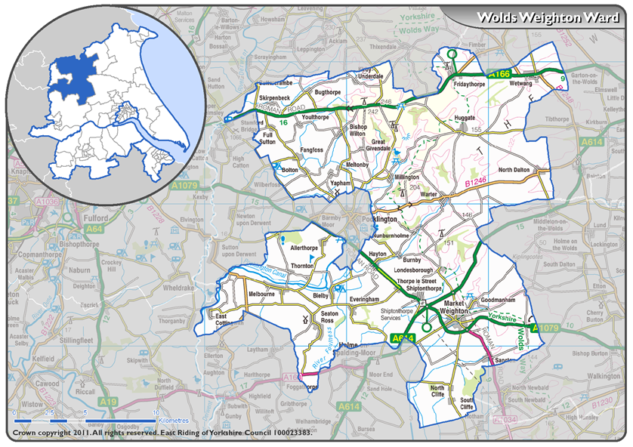

6 Meet your officers

Neighbourhood Watch and Community Alert surgery at Scotts Croft Community Centre:
- PCSO Nikki Cliffe and Maureen Yates (East Riding Council Neighbourhood Watch Co ordinator) will be available at the above location to discuss Neighbourhood Watch and offer crime prevention advice (ie the community alert scheme and Immobilse etc) between 10:00 to 12:00 noon on Tuesday 27th November.

Police “Drop In Surgery” at Market Weighton Library:
- PCSO Nikki Cliffe will be available at the above location to discuss community issues and offer crime prevention advice between 10:00 to 11:00 hours on the 3rd December

