**Wolds Weighton Update for December 2020**

**1. Crime and ASB**

TFMV – Theft from motor vehicle

TOMV – Theft of motor vehicle

ASB – Anti-social behaviour



Detailed crime and ASB data for your area can be obtained by visiting [www.police.uk](http://www.police.uk) and following the ‘Find your Neighbourhood’ link.

**2. Crime issues of particular note**

**The following list shows some of the crimes that have occurred in the previous month in your area.**

* Entry was gained into a garage in Market Weighton and various brass/copper fittings and scrap were taken.
* There was an attempt to steal a trailer parked on a side driveway of a property in Market Weighton.
* A secure vehicle parked at Allerthorpe Woods was broken into and bags of shopping stolen.
* Tools and metal scrap was stolen from a garage in Market Weighton.

**3. Community Priorities**

The Neighbourhood Policing Team meet regularly with partners to ensure we have a multi-agency approach to local issues, individuals and problem solving.  These meetings are regularly attended by partners including Humberside Fire and Rescue Service, Youth and Family Support, Housing Officers, Environmental Health and the East Riding Anti-Social Behaviour Team.  We share information and resources to deal with local neighbourhood issues, in particular, those identified as causing the most harm in the community.

**High Visibility Patrols**

We have been patrolling Market Weighton and the surrounding rural areas during our shifts. We are aware that there are many vulnerable people that live within the community and we want to reassure them that we are still here for you. We have also been posting on Social Media on a regular basis as a way of keeping everyone updated.

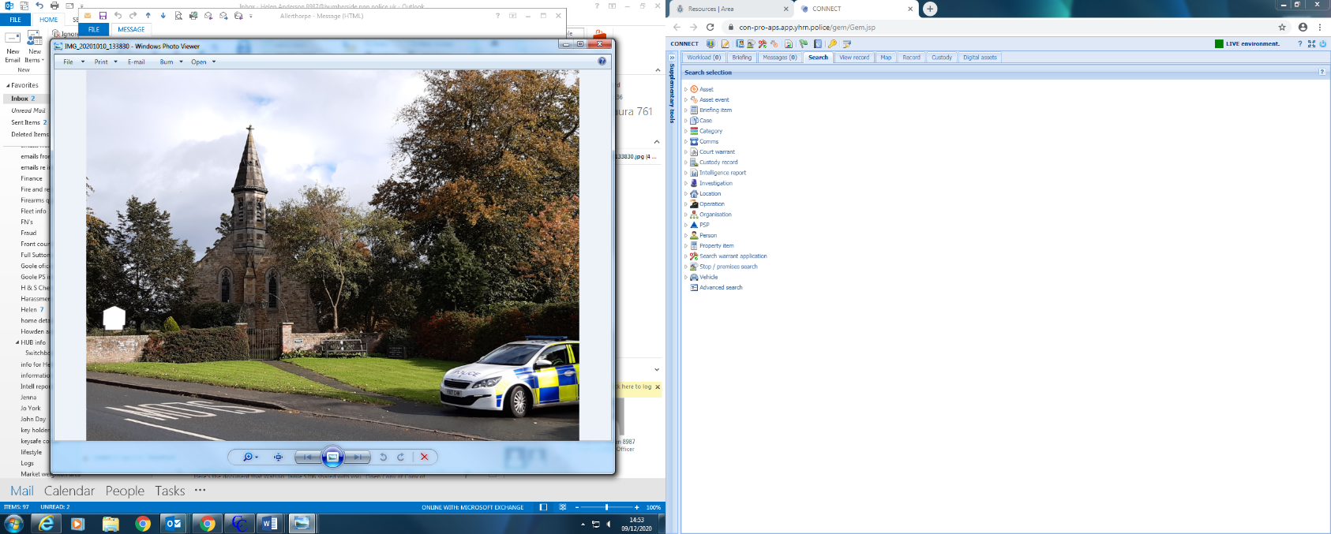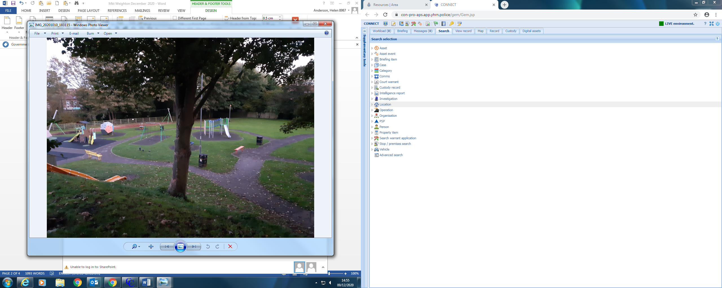

**Operation Yuletide**

Christmas is nearly upon us and on the run up to Christmas you will see an increase in Officers providing high visibility patrol in the Town Centre and around the shops. We want everyone to feel safe and enjoy the festivities so we will be out on foot patrol in the retail areas looking to take positive action against individuals seeking to commit crime.

**4. Crime Prevention Advice**

**WHAT IS A BURGLARY?**

Burglary is by and large an opportunistic crime and there is a lot that you can do to make the burglar look elsewhere. Burglars are looking for a home that gives them the easiest way of committing their crime undetected, with the fewest obstacles to negotiate. However there are things that residents can do to reduce the risk of becoming a victim of burglary.

Follow our tips below:

* If you are away from home (for the day or out at work) try to make your home look occupied by leaving a radio on or lights on timer switches to make the house sound and look occupied.
* Make sure your doors and windows are closed and locked. Nearly half of all burglaries are down to a door or window being open.
* Make sure nothing of value (including your car key) is left on show to tempt thieves into your property.
* If going away in the future– remember to cancel the milk or newspapers. Don’t make it obvious to burglars you are away. Ask a neighbour to remove free newspapers and post from your doormat if they can be seen through a glass panel or through the letterbox.
* Never leave spare keys in a hiding place such as under a doormat, in a flowerpot or inside the letterbox.
* Make sure you use a burglar alarm (if you have one) every time you leave the house. There is no point in having one if you do not use it all the time.
* Secure your gardens with a fence and a lockable gate.
* Consider light weight trellis or spiky plants on top of the fence, to hinder climbing.
* Don’t let bushes and trees hide burglars from view – burglars don’t like being watched!
* Don’t leave tools or ladders in the garden to assist burglars. Secure wheelie bins away from the house and fences.
* Consider a movement activated floodlight if you don’t have one as it unnerves burglars and helps you at night too.

Lastly if your property is stolen make sure you can describe it to the police by keeping a record of makes, models, and unique serial numbers and by also registering the details onto [**www.immobilise.com**](http://www.immobilise.com/)**.** This is a web based property records system, endorsed and searchable by all UK Police Forces and second hand dealers.

If you update the database stating that an item is lost or stolen, it will be highlighted on police and dealer searches and should assist in returning items to their rightful owners and help bring offenders to justice.

**5. News and appeals**

**Operation Galaxy**

It’s now been over 12 months since our Operation Galaxy teams first hit the streets to target those behind the most serious crimes in this area. Below is a snapshot of the story so far from Op Galaxy, our dedicated initiative to target organised crime groups, sex offenders, thieves, drug dealers and those committing domestic abuse to show them they’re not welcome here in our areas. Chief Superintendent Darren Downs, who is leading Operation Galaxy, said:

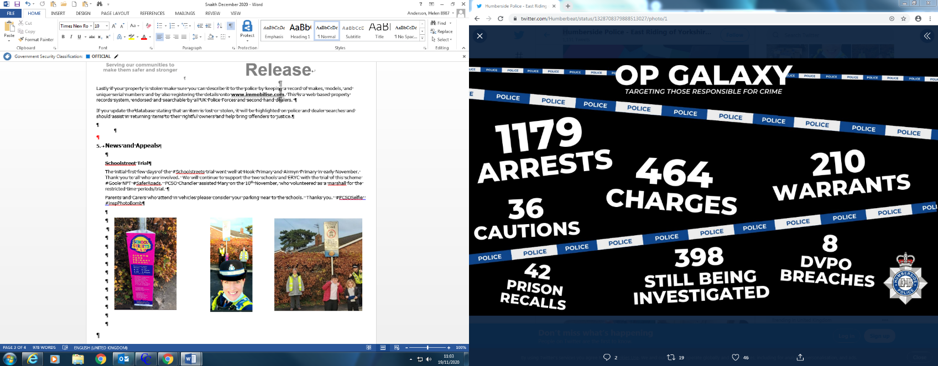“We’re proud of what has been achieved through Operation Galaxy so far but we’re not stopping here. We know from your feedback that you have felt a difference as a result of what we have done so far and that you want us to keep it going. My commitment to you is that we will continue to target these criminals, to ensure it’s known that Humberside is a hostile area that’s not easy for them to operate in.”

If you have concerns about crime in your area, please call our non-emergency 101 line, speak to your local team or, if you’d rather not give your name, call Crimestoppers on 0800 555111. If you or someone else is in immediate danger, always call 999.

**6. Surgeries**

**Online Community Catch up – Zoom Meetings.**

Insp Powell will be hosting a half-an-hour online community catch up via Zoom and he is inviting you to join him. There will also be the opportunity to ask any questions and raise any concerns/issues you may have.  The meetings will be held on the following dates for the Pocklington/Market Weighton & Villages:

5th January 2021 (19:30hrs)

15th February 2021 (14:00hrs)

For details on how to join the meeting, go to the Humberside Police website and type in ZOOM in the “search the site”  section and this will take you to the “on line community catch up page” – click on this link for further information on how to join the meeting or click on the link below.

 (<https://www.humberside.police.uk/CommunityCatchUpNorthbank>)

Stay informed through our social media channels, find us on [Twitter](https://twitter.com/Humberbeat), [Facebook](https://www.facebook.com/humberbeat/) and [Instagram](https://www.instagram.com/humberbeat):

<https://www.humberside.police.uk/teams/wolds-weighton>

Facebook – Humberside Police – East Riding of Yorkshire West

Twitter - Humberside Police – East Riding of Yorkshire West - @Humberbeat_ERYW

For incidents that don’t require an immediate response call our non-emergency 101 line. You can also report [non-emergency crimes online](https://www.humberside.police.uk/non-emergency-crime) via our reporting portal. In an emergency always dial 999.